ULTRASONIC THICKNESS MEASUREMENT REPORT
Company/Client |  | NCOC N. V. |  | Project |  | Eskene West Karabatan |  | Location |  | Unit 331
Line No/Tag No: |  | A1-3311-GA-006-48"-A11-HC |  | Material |  | A11 |  | Día × Nominal Thickness |  | 48 inch × 9,52 mm
Procedure No: |  | QP-11-UTT-Q01 Rev 02  GOST 28702-90 |  | Calibration Block |  | CS Step wedge |  | Probe  S/N |  | D790  1058416
 |  |  |  | Calibration block Range |  | 2,5-25 mm |  | Angle |  | 0º
Manufacturing Code |  | ASME B31.3 |  | Calibration Temp |  | -2º |  | Frequency |  | 5 MHz
 |  |  |  | Object Temp |  | +190º- +260º |  | Size |  | 11 mm
Acceptance Standard: |  | Client specification  STN-00-226-P-SP-0006 Rev.A01 |  | Correction factors |  | Calculated by 38DL in high temperature mode automatically |  | Crystal |  | Dual
Surface condition |  | Coated |  | Couplant |  | High temperature UT Gel ʺHiTempco" |  | Accuracy |  | ± 0,1 mm
S. No | Equipment/  Material Name |  | Manufacturer |  | Serial No |  | Calibration certificate No |  | Calibration Expiry date
 | A-scan UT |  | OLYMPUS DL-38 |  | 171421601 |  | 2113237 |  | 02.04.2019
 | Step wedge calibration block |  | NDE Tech |  | NDE-8363 |  | 4739 |  | 09.05.2019
 | Thermometer |  | - |  | 91778 |  | N/A |  | N/A
Job description:
- Echo-to-echo and standard UT technique was used, it depends on surface condition and possibility of detection second back will echo.
- UT spot check performed on 12:00, 1:30, 3:00, 4:30, 6:00, 7:30, 9:00, 10:30 O’clock of 48ʺ pipe.
- Inspection performed from external side and measurement was done through protection coat.

Legend:
N/A: Not Applicable

DETAILS AND RESULTS & PHOTO
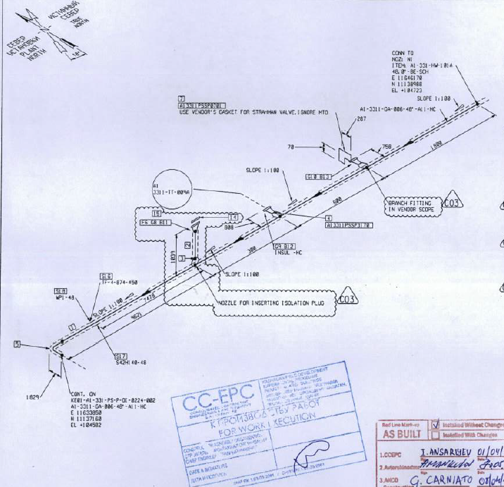  1000mm  Location 1A  KE01-A1-331-PS-P-DI-0224-001  Control area | 0 starts at 1000 mm downstream from vessel and at 20 mm below longitudinal weld.  Standard UT technique was used.  All data include coating.  Flow  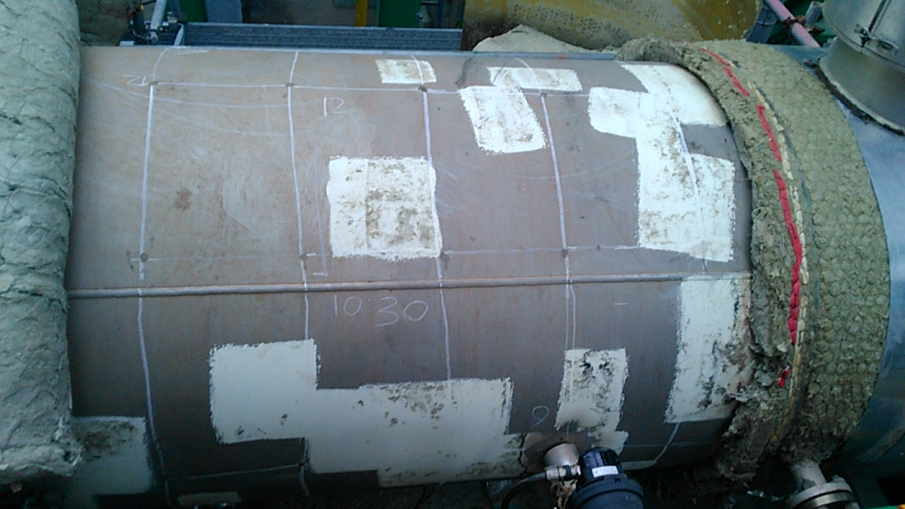  0 (datum)  X  Y  Location 1A

Item description | inch | Nominal thickness, mm | Location* |  | Distance of X axis, mm
 |  |  |  |  | 0 | 300 | 600 | 900 | 1200
Pipe  (Location 1A) | 48″ | 9,52 | Distance of Y axis, mm  (O’clock position) | 0 (3:00) | 10.12 | 10.18 | 10.23 | 10.39 | 10.73
 |  |  |  | 480 (4:30) | 10.65 | 10.30 | 10.75 | 10.84 | 10.56
 |  |  |  | 955 (6:00) | 10.37 | 10.19 | 10.47 | 10.32 | 10.53
 |  |  |  | 1435 (7:30) | 10.26 | 10.13 | 10.13 | 10.32 | 10.51
 |  |  |  | 1910 (9:00) | 10.03 | 9.83 | 9.64 | 9.91 | 10.59
 |  |  |  | 2390 (10:30) | 10.06 | 9.88 | 9.77 | 10.17 | 10.26
 |  |  |  | 2870 (12:00) | 10.21 | 10.01 | 9.78 | 9.91 | 9.98
 |  |  |  | 3345 (1:30) | 10.32 | 10.41 | 10.23 | 10.81 | 10.83

Notes:
*Distance measure from longitude weld in clock wise direction (see photo above).

DETAILS AND RESULTS & PHOTO
Location 2A  KE01-A1-331-PS-P-DI-0224-001  Control area | 0 starts at 100 mm downstream from circumferential weld and 20 mm below longitudinal weld.  Standard UT technique was used.  All data include coating.  Flow  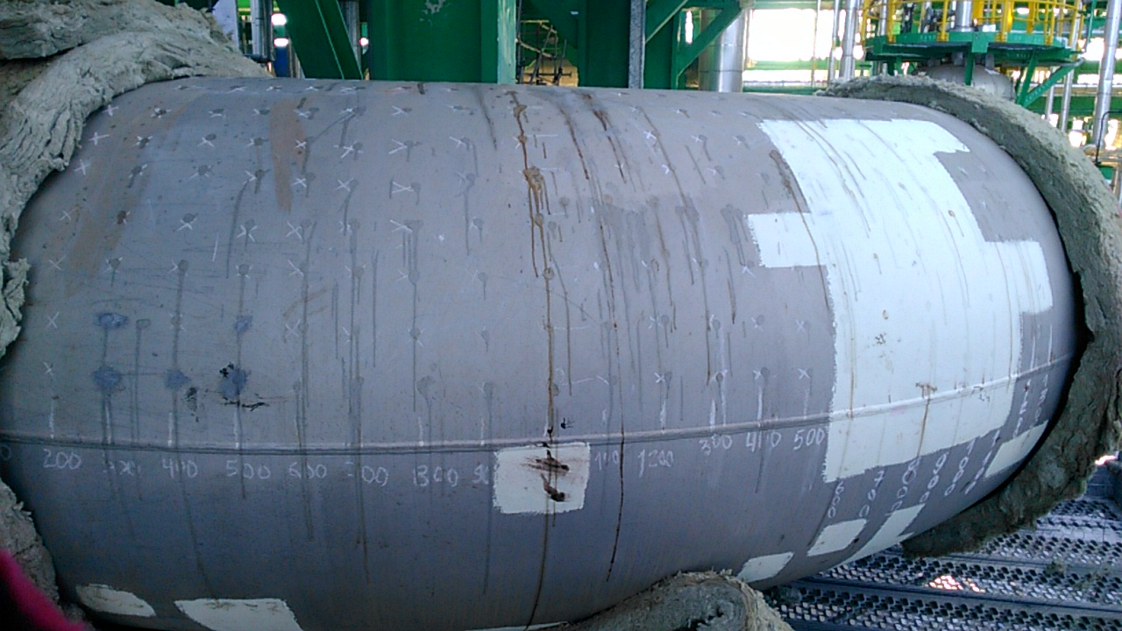  X  Y  0 (datum)  Location 2A

Item description | inch | Nominal thickness, mm | Location* |  | Distance of X axis, mm
 |  |  |  |  | 0 | 400 | 800 | 1200 | 1600 | 2000 | 2400 | 2800 | 3200 | 3600
Elbow  (Location 2A) | 48 | 9,52 | Distance of Y axis, mm  (O’clock position) | 0 (3:00) | 10.72 | 10.57 | 10.61 | 10.27 | 10.69 | 10.76 | 10.50 | 11.36 | 11.39 | 10.29
 |  |  |  |  | 0 | 375 | 750 | 1125 | 1500 | 1875 | 2250 | 2625 | 3000 | 3375
 |  |  |  | 480 (4:30) | 10.72 | 11.24 | 11.57 | 11.03 | 11.66 | 11.16 | 11.49 | 10.91 | 11.04 | 10.82
 |  |  |  |  | 0 | 295 | 590 | 885 | 1180 | 1475 | 1770 | 2065 | 2360 | 2655
 |  |  |  | 955 (6:00) | 10.39 | 10.36 | 10.68 | 10.13 | 10.83 | 10.71 | 10.48 | 10.57 | 10.03 | 10.44
 |  |  |  |  | 0 | 215 | 430 | 645 | 860 | 1075 | 1290 | 1505 | 1720 | 1935
 |  |  |  | 1435 (7:30) | 11.12 | 10.95 | 11.52 | 10.79 | 10.91 | 10.68 | 11.18 | 11.34 | 11.11 | 11.47
 |  |  |  |  | 0 | 190 | 380 | 570 | 760 | 950 | 1140 | 1330 | 1520 | 1710
 |  |  |  | 2010 (9:00) | 11.23 | 10.49 | 11.32 | 10.99 | 11.79 | 12.05 | 11.50 | 11.67 | 11.17 | 11.24
 |  |  |  |  | 0 | 215 | 430 | 645 | 860 | 1075 | 1290 | 1505 | 1720 | 1935
 |  |  |  | 2390 (10:30) | 10.44 | 10.60 | 10.59 | 10.87 | 9.94 | 11.04 | 10.90 | 10.87 | 11.12 | 10.78
 |  |  |  |  | 0 | 295 | 590 | 885 | 1180 | 1475 | 1770 | 2065 | 2360 | 2655
 |  |  |  | 2870 (12:00) | 10.55 | 10.65 | 10.77 | 10.95 | 10.71 | 11.06 | 10.45 | 11.21 | 11.35 | 10.98
 |  |  |  |  | 0 | 375 | 750 | 1125 | 1500 | 1875 | 2250 | 2625 | 3000 | 3375
 |  |  |  | 3345 (1:30) | 10.53 | 11.08 | 11.44 | 11.98 | 11.35 | 11.28 | 11.45 | 11.50 | 11.59 | 11.23

Notes:
*Distance measure from longitude weld in clock wise direction (see photo above).

DETAILS AND RESULTS & PHOTO
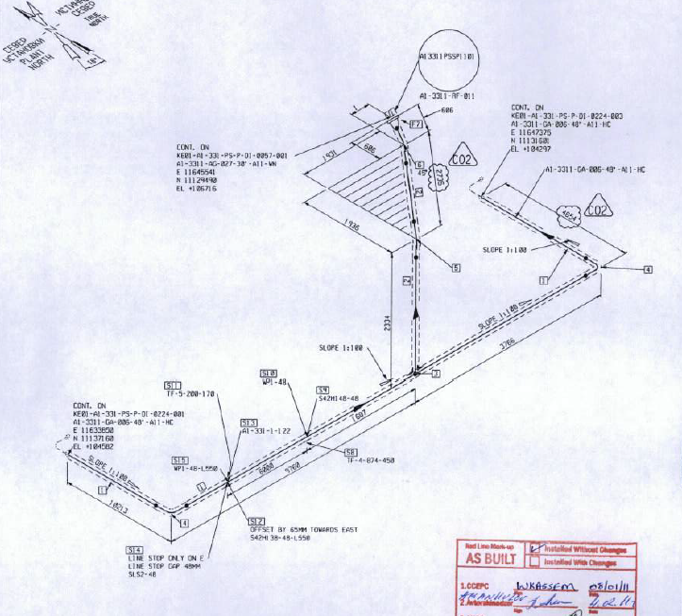  2750  Location 3A  KE01-A1-331-PS-P-DI-0224-002  Control area | 0 starts at 3650 mm upstream from tee and 20 mm below longitudinal weld.  Echo-to-echo technique was used all measurements provided without coating.  Flow  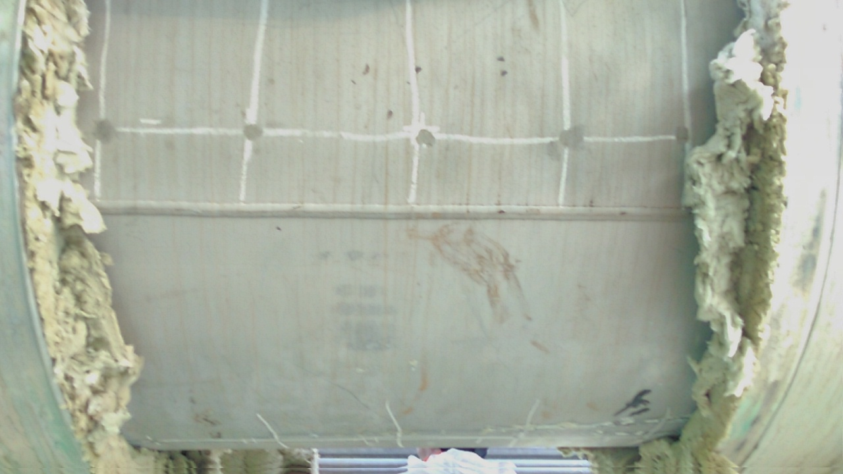  0 (datum)  X  Y  Location 3A

Item description | inch | Nominal thickness, mm | Location |  | Distance of X axis, mm
 |  |  |  |  | 0 | 200 | 400 | 600 | 800
Pipe  (Location 3A) | 48″ | 9,52 | Distance of Y axis, mm  (O’clock position) | 0 (3:00) | 9.08 | 8.77 | 8.82 | 8.81 | 8.97
 |  |  |  | 480 (4:30) | 8.94 | 8.90 | 8.80 | 8.84 | 8.84
 |  |  |  | 955 (6:00) | 8.86 | 8.81 | 8.70 | 8.78 | 8.77
 |  |  |  | 1435 (7:30) | 9.09 | 8.83 | 8.97 | 8.93 | 8.92
 |  |  |  | 1910 (9:00) | 8.73 | 8.99 | 9.85 | 9.31 | 8.96
 |  |  |  | 2390 (10:30) | 8.90 | 8.76 | 8.84 | 8.76 | 8.90
 |  |  |  | 2870 (12:00) | 9.03 | 9.00 | 9.13 | 8.83 | 8.97
 |  |  |  | 3345 (1:30) | 8.87 | 9.75 | 8.77 | 8.76 | 8.78

Examined by  UT L II cert. No 263  exp. date: 08.01.2021 | Name: Zakharov Vadim | Signature:..................................... | Date: 25 Dec 2018
Approved by  UT L III cert. No 1A123/15  expiry date 29.02.2020 | Name: Shundryk Ihar | Signature:..................................... | Date: 25 Dec 2018
Client Representative: | Name:…………………………… | Signature:..................................... | Date: …………………………
Notes:
*Distance measure from longitude weld in clock wise direction (see photo above).

